|  |  |
| --- | --- |
|  |  |

**DEPARTMENT OF COMPUTER SCIENCE AND ENGINEERING**

## MANAGEMENT INFORMATION SYSTEM WITH COMMERCE

## CSA4053

**U.VINEETHA  
 192011398**

**1.** **Draw a UML diagram for hotel reservation system. In a hotel reservation system, a**

**customer can make online booking for a hotel, by specifying the accommodation**

**requirements such as type of room (AC/Non-AC, One bed/two bed), total no of rooms,**

**duration of stay. The system selects a suitable hotel as per customer’s requirements. If**

**a hotel is found then the availability of rooms in that hotel is checked. The charges are**

**calculated for the selected requirement and these are acknowledged to the customer. If**

**the customer is satisfactory about the selection made by the system, then he confirms**

**the reservation.**

**USECASE:**

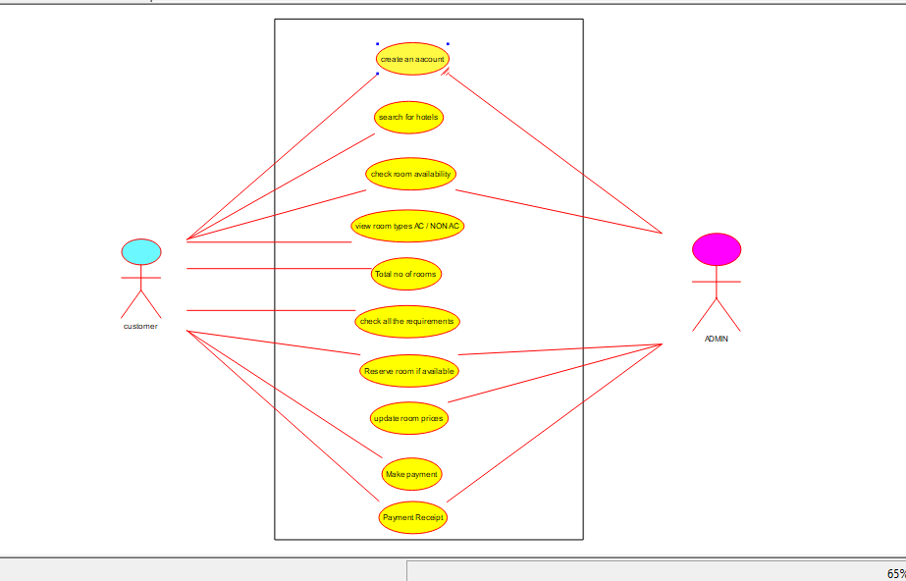

**STATE CHART DIAGRAM:  
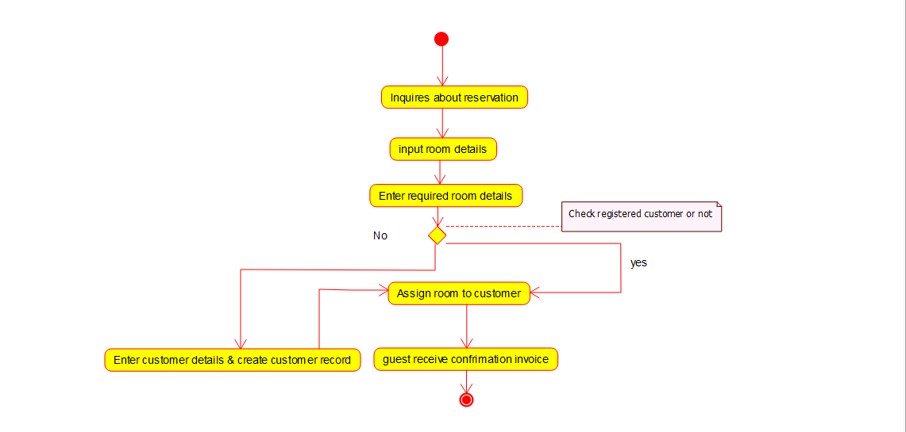**

**2.** **Draw a coffee day ordering system. A coffee day shop vending machine**

**dispenses coffee to customers. Customers order coffee by selecting a recipe from a set**

**of recipes. Customers pay for the coffee using coins. Change is given back, if any, to**

**the customers. The ‘service assistant’ loads ingredients (coffee powder, milk, sugar,**

**water, chocolate) into the coffee machine. The ‘service assistant’ adds recipe by**

**indicating the name of the coffee, the units of coffee powder, milk, sugar, water,**

**chocolate to be added as well as the cost of the coffee. The service assistant can also**

**edit and delete a recipe. Develop the use case diagram for the specification above.**

**USECASE:**

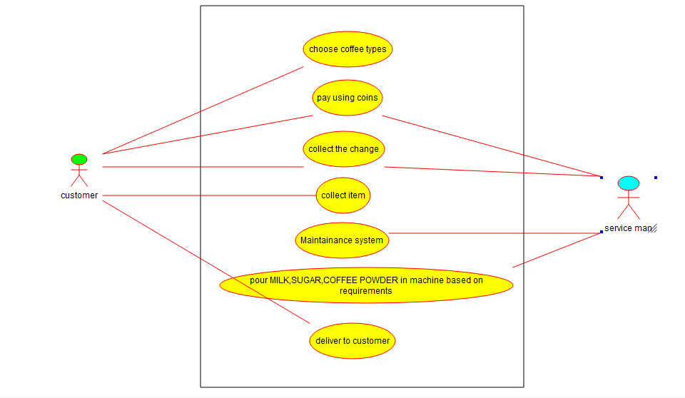

**3) Make an Online Airline Reservation System. The activities of the Online Airline**

**Reservation system are listed below user, admin, LOGIN, MANANGE CLASSES,**

**MANANGE WAITING LIST, MANAGE HOLDS, MANAGE DEADLINES,**

**LOGOUT, using this has a step-by-step process draw a CLASS diagram.**

**CLASS DIAGRAM:**

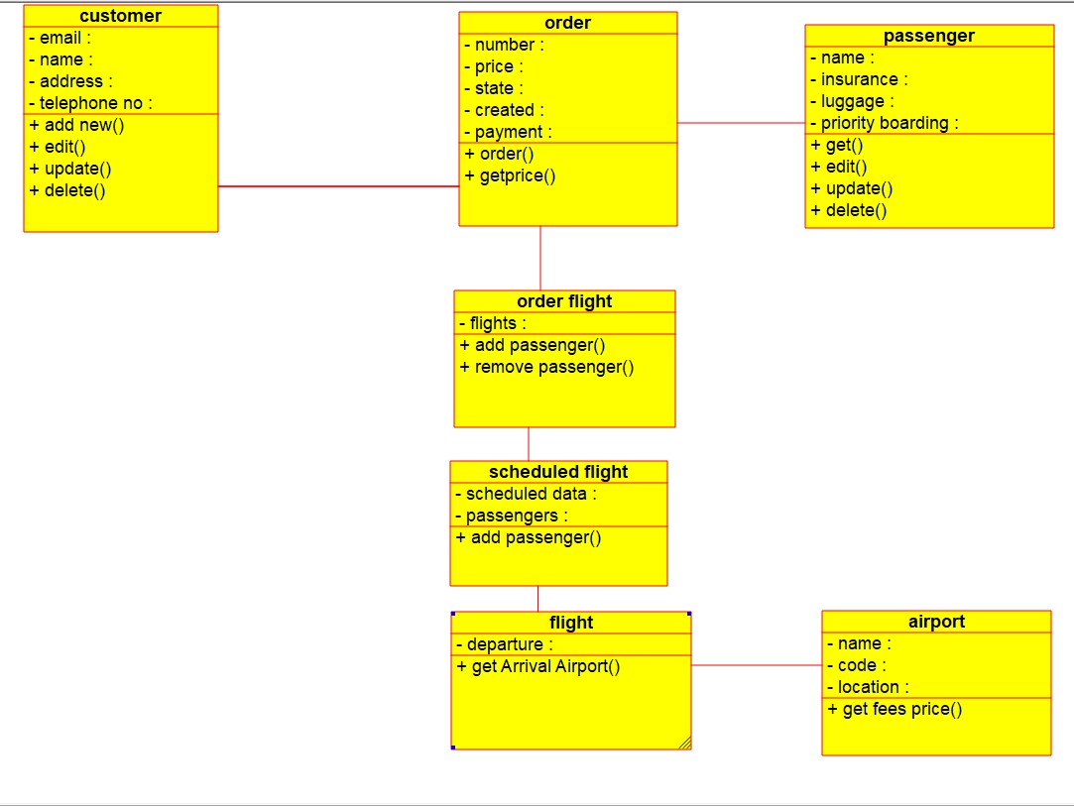

**4) Draw a UML diagram for ATM System using CASE tool. The banking system allows**

**a customer to access the financial transactions by ATM System, it has a step-by-step**

**process describe the work of this process and elaborate the what are the work can do by**

**customer, banking system, administrator and technicians with the ATM system.**

**USECASE:**

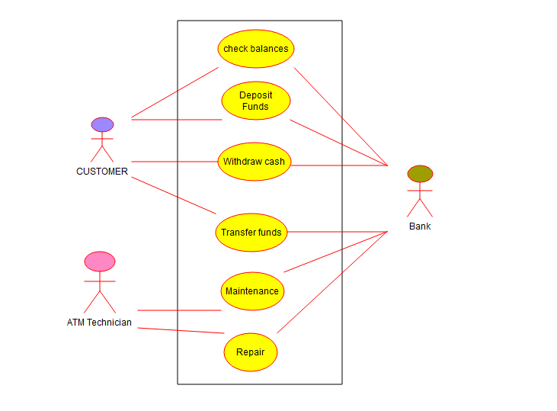

**COMPONENT DIAGRAM:**

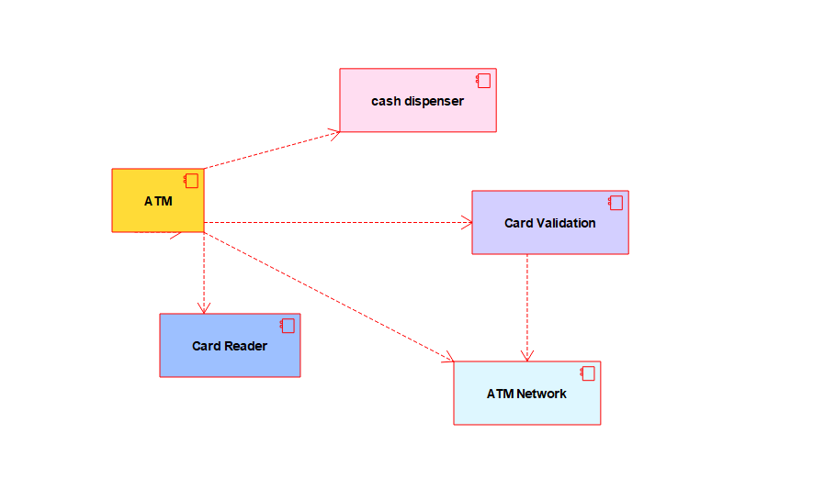

**5) Draw a UML diagram for a food ordering system Systems. The activities of the food**

**ordering system are listed below. Receive the Customer food orders, Produce the**

**customer ordered food, Serve the customer with their ordered food, collect payment**

**from Customers, Store customer payment details, Order Raw Materials for food**

**products, Pay for Raw Materials and Pay for Labour.**

**USECASE:**

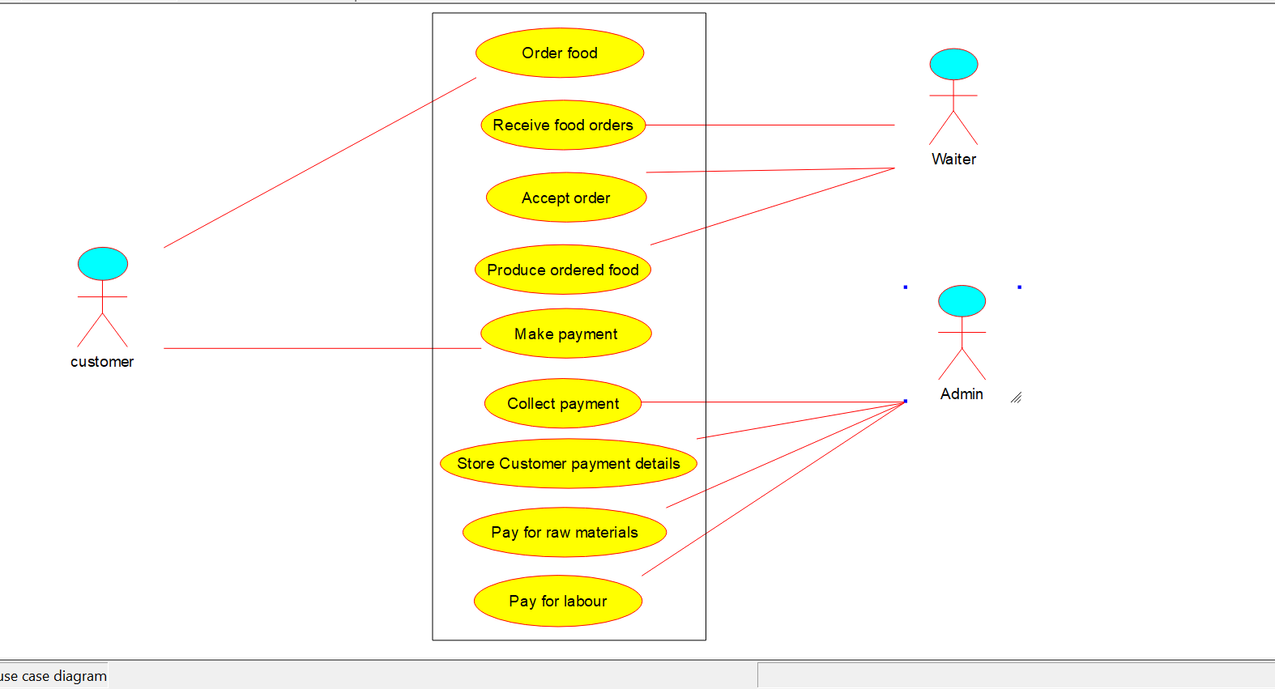

**SEQUENCE DIAGRAM:**

